
Company
Logotype

Cone Beam Computed Tomography- Report



Porur Dental X-rays & CBCT

Patient Name : Mr. Ramesh Kumar | Date of Report : 16.11.2024
Age/ Gender : 43 years/ Male | Region of Interest : CBCT TMJ
Referring doctor: VJ Dental Studio | Indication : Temporomandibular joint assessment
Clinical Notes: Nil
PATIENT INFORMATION

CBCT- Tomo provided
CBCT – IMAGE DETAILS

RADIOGRAPHIC INTERPRETATION

During rest position – Right Temporomandibular joint:
- In relation to the right temporomandibular joint, presence of mild degenerative changes in the superior surface of the head of the condyle causing mild flattening is evident.
- A hyperdense sclerotic line evident along the medial aspect of the condylar head, running from superior surface to medial surface.
- The condylar head lies below the articular eminence during rest position.

During rest position – Left Temporomandibular joint:
- In relation to the left temporomandibular joint, moderate to severe degenerative changes in the superior surface of the head of the condyle causing morphological alteration of the condylar head is evident.
- Flattening of the articular eminence is also evident.
- Sclerotic changes evident along the medial and superior aspect of the condylar head.

During open mouth position - Temporomandibular joint:
- In relation to the right and left temporomandibular joint, the head of the condyle appears to be placed out of the mandibular fossa and is present anterior to and ahead of the articular eminence (excessive forward gliding of the condylar head).

RADIOGRAPHIC IMPRESSION

- Temporomandibular Joint Dysfunction: right and left side.

Kindly correlate with clinical findings


IMAGES FOR REFERENCE

Coronal view:
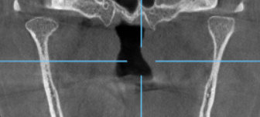

RIGHT TEMPOROMANDIBULAR JOINT

At rest:
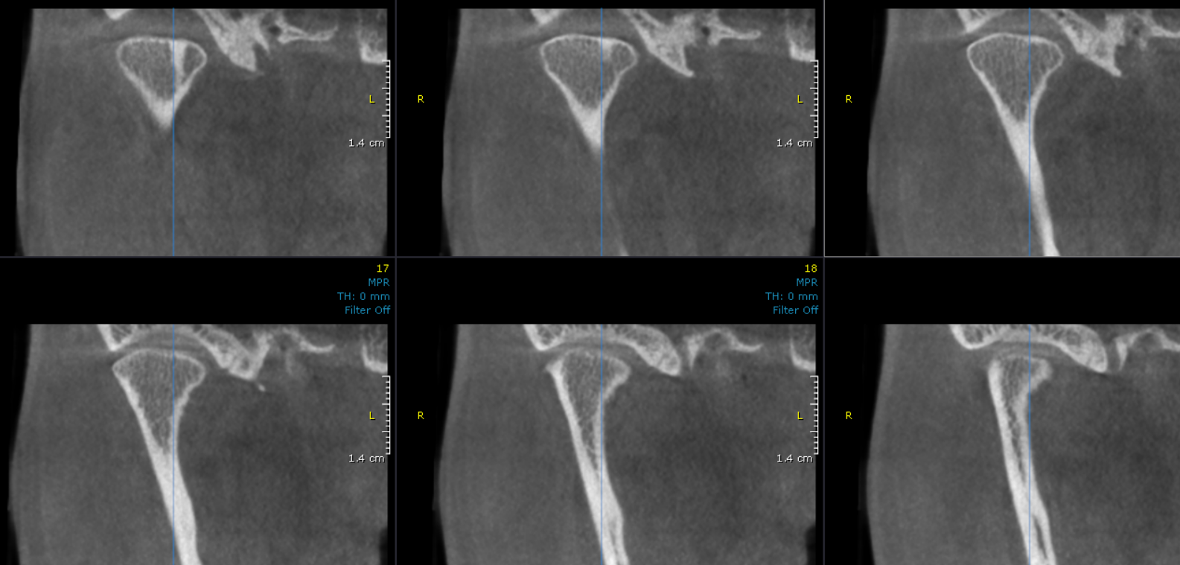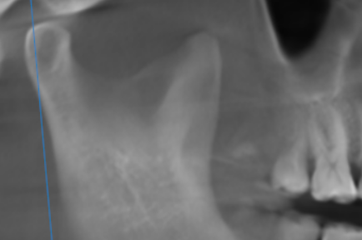

LEFT TEMPOROMANDIBULAR JOINT

At rest:
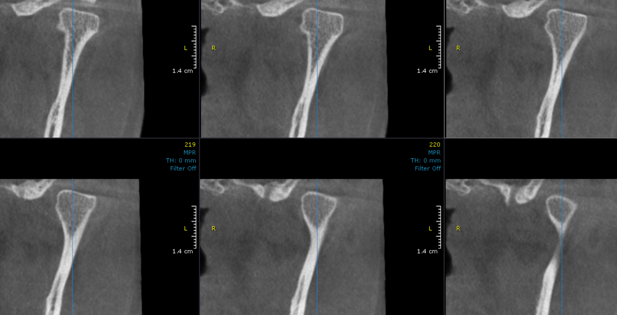

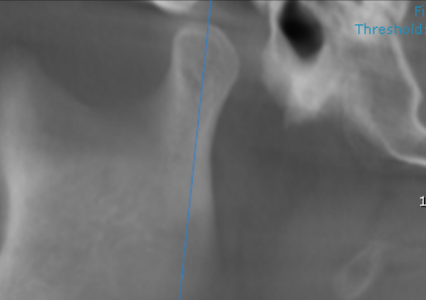

Left TMJ during mouth opening:
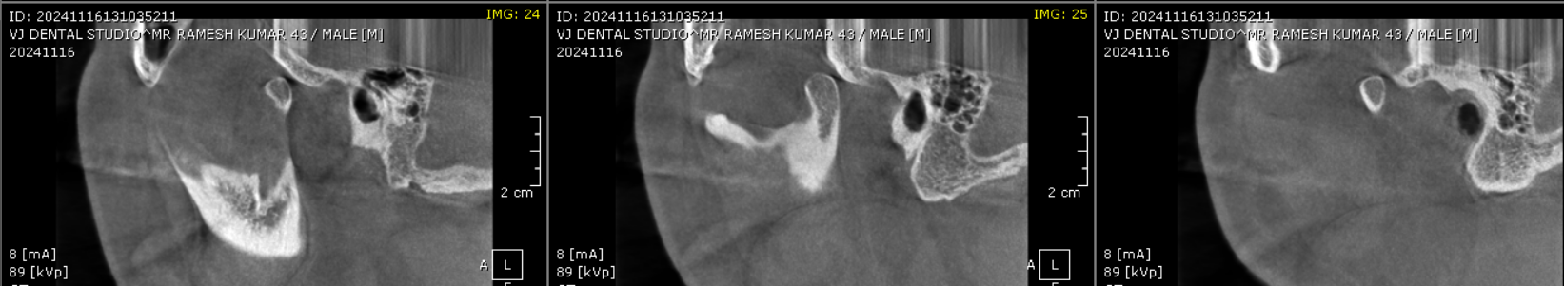

Right TMJ during mouth opening:
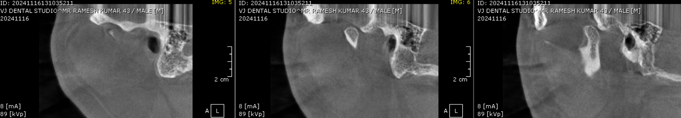**** End of report ****

